CENWP-OD-J
20 May 2010
MEMORANDUM FOR THE RECORD

SUBJECT: Dead juveniles at JDA SMF.

Starting the week of 17 April, PSMFC Smolt Monitoring personnel observed “Salmonid mortalities at the SMF have been a bit higher than the historical expectations this week, and approximately 80% (22 of 28) of the mortalities were either headless fish bodies or bodiless fish heads. As yet, no obvious causes of the unusual mortalities have been identified but we believe the injuries could be caused by a partially open gatewell orifice. No dead fish have been noted during gatewell surface inspections and gatewells continue to be cycled 3 times per day.”

The week of 24 April, Smolt Monitoring personnel noted “Salmonid mortalities at the SMF have continued to be a problem this week with numbers well above historical averages. Gatewell orifices were all open and ran un-cycled for 24 hours to check if the mortality issue was orifice related. After the 24hr period our morning sample on April 30 still had 8 mortalities with the same head injuries as previous samples. USACE facility staff is looking into other possible problems.” They included the photos below in their JDA Weekly Report 5.
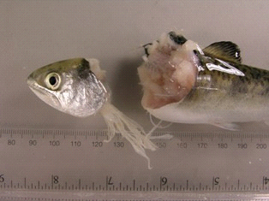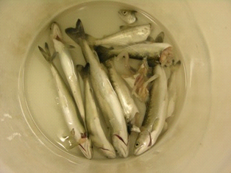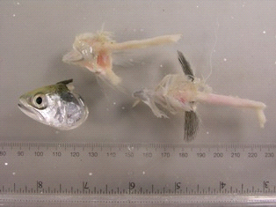
JDA stopped cycling all orifices on 29 April for 24 hrs but it did not result in any change; the morts were still found in the next day sample.

On 3 May, JDA Maintenance staff raked trashracks. JDA Fisheries staff checked all orifice valve performance, maintenance and cycling procedures. Fisheries felt the violent type of injuries indicate high velocities and a protrusion/restriction/blockage the fish may be hitting. Fisheries inspected gatewells and STSs but due to lack of any signs of injured fish, plus video inspection from 19 April, did not determine any problems with them.

Fisheries suspect the orifices may be causing the mortalities. They proceeded trying to isolate the problem. Fisheries noted that the decapitated fish are not de-scaled, ditto for the overall condition with most fish (98% and higher) in perfect condition. They also noted that the only other area of high velocity is the elevated chute, downstream of the tainter gate to hydraulic jump.

On 5 May, JDA Fisheries staff, with PSMFC biologists dewatered the lower SMF at 1000 to 1100 hrs with minimal impact on sampling or fish safety. They did not find any problems in any downstream flumes and all juvenile fish evacuated the system in excellent condition through the dewatering flume. They did observe three fish heads and three morts (including headless body) floating down through the dry separator after the transport flume flow was shut down. Based on that information, the problem appears to be upstream of the primary dewatering structure.

- Species – salmonids
- Origin – NA
- Length – NA
- Weight – NA
- Marks and Injuries noted during tagging – NA
- Marks and Injuries found on the carcass – headless bodies, body-less heads
- Cause and Time of Death – Cause presumed to be beheading. Not sure of where in the JBS.
- Future and Preventative Measures – JDA Fisheries will inspect and manually pull on plates, grates, etc during winter maintenance. The plates found to be the cause of the morts were inspected during the winter but the deficiencies were not apparent at that time.

17 May Update- The orifice inspection was completed on 14 May. Unit 5 and Unit 8 orifices were cycling slower than the others, but all orifices were found fully closing and opening. JDA plans to not cycle orifices at MU 5 & 8 for 24 hrs effective immediately.

18 May Update- No problems seen with JDA gatewell orifices' operations and maintenance. Fisheries expanded the scope of the JBS investigation to include more areas. 100 PIT tagged smolts will be released into the JBS collection channel at MU16 (far end of it) on 20 May and then separated by code by the SMF's 3-way gate. The purpose of this release is to narrow down the search for an area where the JBS mortalities could be occurring.

19 May Update- JDA maintenance will be closed the JBS tainter gate for a visual inspection of areas downstream of it. The expansion joint just downstream of the tainter gate had a metal plate covering the gap between the cement sections and had come loose (one plate on each side of the elevated chute). The portion of the plate above the water-line appeared well fastened, but both sides pulled away from the wall when water was moving past them. The gaps were about 1-2 inches and several feet from top to bottom. The mechanical crew detached the metal plates from the floor and reopened the tainter gate.

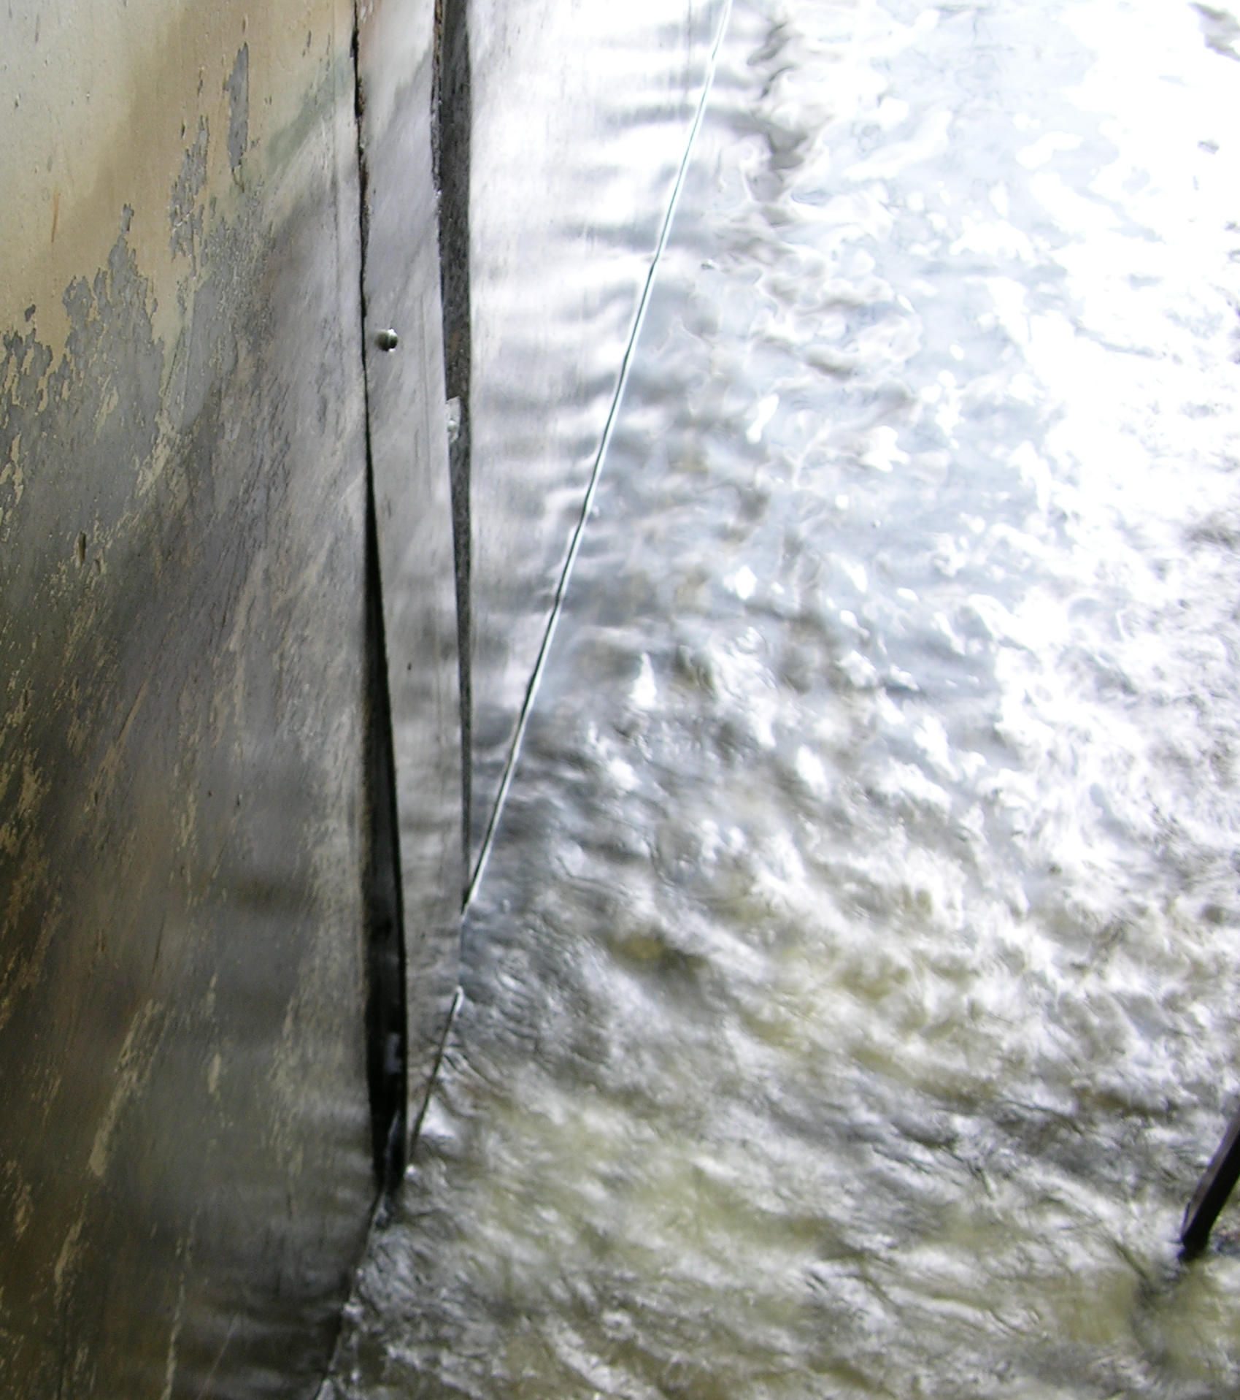 Photo of metal plates in the flume.

20 May Update- The morning sample had only 4 morts as compared with 27 yesterday.

As previously scheduled, and to make sure the issue has been resolved, 100 PIT tagged fish were released into JD JBS collection channel at MU 8 at approximately 0855 on 20 May. The first fish where heard to be diverted by SMF 3 gate approximately 12 minutes later.

MIROSLAW A. ZYNDOL
JOHN DAY DAM
CHIEF OF FISHERIES

